CR Estuary Avian Counts from 5/11 - 5/12
 | CATE | Scrapes | Eggs | DCCO
ESI Main colony | ~2000 | - | >2 | <20
ESI South Beach | 580 | 80 | 0 | 0
Rice Island | 210 | 260 | 1 | 0
E. Rice Pile Dike | 0 | 0 | 0 | 840
Miller Sands | 0 | 0 | 0 | 0
Pillar Rock | 0 | 0 | 0 | 0
Pillar Rock Pile Dike | 0 | 0 | 0 | 278

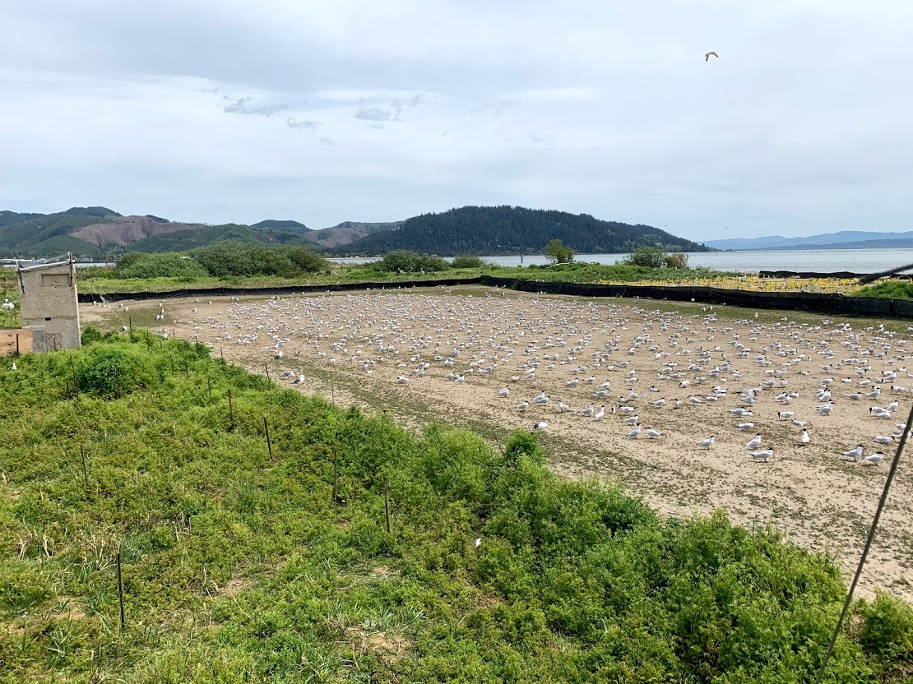
ESI Colony looking East May 5th.
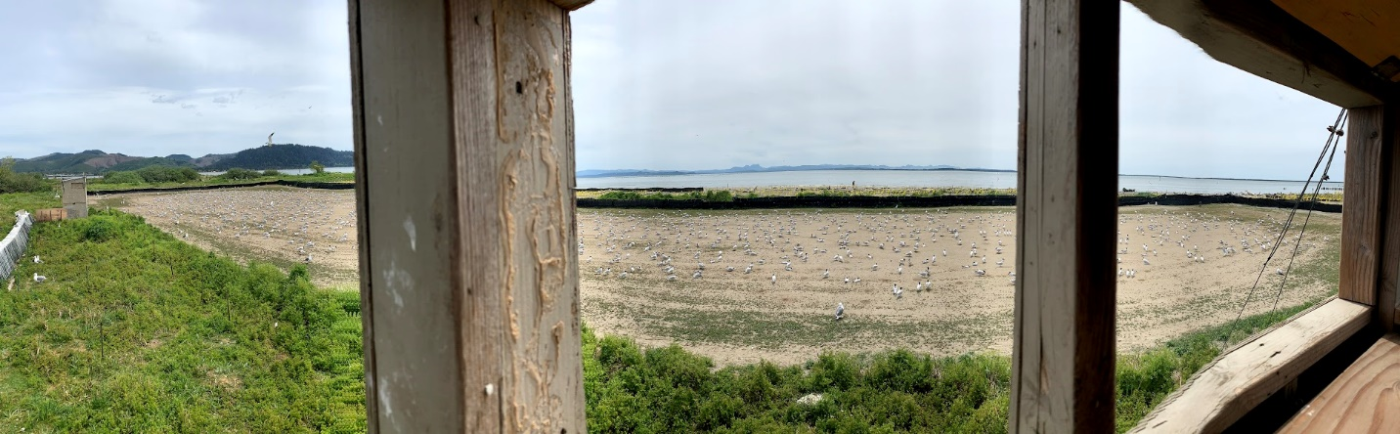
ESI Colony Panoramic May 5th.

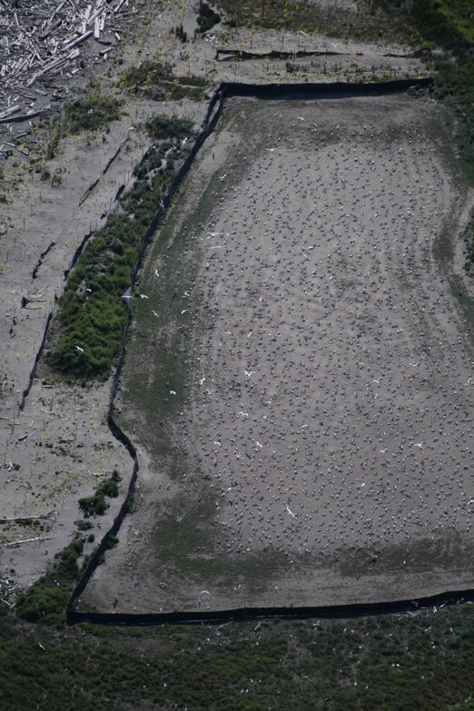
ESI CAP flight 5/12

